See discussions, stats, and author profiles for this publication at: [https://www.researchgate.net/publication/301293322](https://www.researchgate.net/publication/301293322_Bank_Account_Management_System?enrichId=rgreq-f2a8c43f5275f06e3165f85e2637f365-XXX&enrichSource=Y292ZXJQYWdlOzMwMTI5MzMyMjtBUzozNTA5MTIzNTE2MjExMjFAMTQ2MDY3NTQzMjYyMw%3D%3D&el=1_x_2&_esc=publicationCoverPdf)

[Bank Account Management System](https://www.researchgate.net/publication/301293322_Bank_Account_Management_System?enrichId=rgreq-f2a8c43f5275f06e3165f85e2637f365-XXX&enrichSource=Y292ZXJQYWdlOzMwMTI5MzMyMjtBUzozNTA5MTIzNTE2MjExMjFAMTQ2MDY3NTQzMjYyMw%3D%3D&el=1_x_3&_esc=publicationCoverPdf)

**Thesis** · June 2015

DOI: 10.13140/RG.2.1.4335.9120



CITATIONS READS

0 69,543

* **authors**, including:

[Md. Jasim Uddin](https://www.researchgate.net/profile/Md_Jasim_Uddin5?enrichId=rgreq-f2a8c43f5275f06e3165f85e2637f365-XXX&enrichSource=Y292ZXJQYWdlOzMwMTI5MzMyMjtBUzozNTA5MTIzNTE2MjExMjFAMTQ2MDY3NTQzMjYyMw%3D%3D&el=1_x_5&_esc=publicationCoverPdf)



City University of Bangladesh

**8** PUBLICATIONS **27** CITATIONS



[SEE PROFILE](https://www.researchgate.net/profile/Md_Jasim_Uddin5?enrichId=rgreq-f2a8c43f5275f06e3165f85e2637f365-XXX&enrichSource=Y292ZXJQYWdlOzMwMTI5MzMyMjtBUzozNTA5MTIzNTE2MjExMjFAMTQ2MDY3NTQzMjYyMw%3D%3D&el=1_x_7&_esc=publicationCoverPdf)

All content following this page was uploaded by [Md. Jasim Uddin](https://www.researchgate.net/profile/Md_Jasim_Uddin5?enrichId=rgreq-f2a8c43f5275f06e3165f85e2637f365-XXX&enrichSource=Y292ZXJQYWdlOzMwMTI5MzMyMjtBUzozNTA5MTIzNTE2MjExMjFAMTQ2MDY3NTQzMjYyMw%3D%3D&el=1_x_10&_esc=publicationCoverPdf) on 14 April 2016.

The user has requested enhancement of the downloaded file.

**Project Topic On**

“**Bank Account Management System**”

**By**

Md. Jasim Uddin

ID NO: **11328503**

**&**

Md. Nuruzzaman

ID NO: **11328473**

**Submitted To:**

Department of **C**omputer **S**cience & **E**ngineering

in partial fulfillment of the requirements for the degree of BSc in Computer Science & Engineering (CSE)



Department of **C**omputer **S**cience & **E**ngineering

City University

Dhaka, Babgladesh

Date: **June, 2015**

**Supervised by:**

Ayesha Siddika

Coordinator & Lecturer

Department of CSE

Developed by Md. Jasim Uddin & Nuruzzaman (BCSE/28th Batch)

Final year project has been accepted in partial fulfillment of the requirements for the degree of BSc in Computer Science & Engineering (CSE)

**Project Advisor**

................................................................

**Ayesha Siddika (Supervisor)**

Coordinator & Lecturer,

Department of CSE

City University

**Project Examiner**

.....................................................

............................................................

**Md. Safaet Hossain**

Head of the Department

Computer of Science & Engineering

City University

**Prof. Dr. Matiur Rahman Mian**

Professor & DEAN

Faculty of Science & Engineering

City University

Developed by Md. Jasim Uddin & Nuruzzaman (BCSE/28th Batch)

**PROJECT ON**

**“Bank Account Management System”**

Developed by Md. Jasim Uddin & Nuruzzaman (BCSE/28th Batch)

**Declaration**

I, Md. Jasim Uddin and my project group partner Md. Nuruzzaman, declare that the project report entitled “Bank Account Management System” submitted to City University for consideration of degree of Bachelor of Computer Science & Engineering (CSE) embodies our own work with suggestion received during the work, which have been suitably acknowledged.

Signed: (..................................), Date: .........................................…….

**Md. Jasim Uddin (11328503)**

Signed: (......................………..), Date: .........................................…….

**Md. Nuruzzaman (11328374)**

Developed by Md. Jasim Uddin & Nuruzzaman (BCSE/28th Batch)

**Approval**

I certify that this project “Bank Account Management System” is the original work of the above named candidate and has been done under my supervision. To the best of my knowledge and belief, this work which embodies the work of candidates themselves, has been duly completed, fulfills the requirement of the ordinance relating to the final year of City University and is up to standard in respect of content, presentation and language for being referred to the examiner. The work has never been submitted anywhere. It’s only submitted to City University.

**Project Advisor:**

Signed: ......................................, Date: .....................................

**Ayesha Siddika (Supervisor)**

**Coordinator & Lecturer,**

**Department of CSE**

**City University**

Developed by Md. Jasim Uddin & Nuruzzaman (BCSE/28th Batch)

**Acknowledgements**

I would like to express my deepest sense of gratitude to my reverend teacher and supervisors **Ayesha Siddika**, Coordinator & Lecturer, Department of Computer Science & Engineering(CSE), City University, and, for her untiring guidance, constant supervision, enthusiastic encouragement, sagacious advice and an effective surveillance throughout the entire period of my project & thesis work and preparation of the manuscript. I greatly say thank you. Wish to express my heart full thanks to all of my honorable teachers of the Department of Computer Science & Engineering (CSE), City University.

I sincerely thank our Head of Department Md. Safaet Hossen for giving me the chance as well as the support for all the time being.

I am thankful to Mrs. **Ayesha Siddika**, who is having a vast knowledge of DBMS & MYSQL, System Analysis and Design & Programming concepts which are the building block of project.

I also want to express my appreciation to my classmates and friends who helped me in one way or another during the course of developing this project. They endured the long hours of my absence during the development of this project.

I also wish to thanks to the members of **Mutual Trust Bank**, for providing me some banking software specifications and for their cordial behavior during my project & thesis work.

I deeply express my respect to my parent and my teachers for their blessing and constant inspiration in every step of my education. I am very thankful to my all friends for their help and company during the project & thesis work and for giving me the encouragement to carry out the work.

Finally, I express my gratitude to the Almighty Allah, the most beneficent & the most merciful, for granting me the opportunity to write this intern project report.

**June, 2015**

Md. Jasim Uddin (**11328503**) **&**

Md. Nuruzzaman (**11328374**)

Dept. of Computer Science & Engineering (**CSE**)

**City University**

Developed by Md. Jasim Uddin & Nuruzzaman (BCSE/28th Batch)

**Abstract**

The Bank Account Management System is an application for maintaining a person's account in a bank. In this project I tried to show the working of a banking account system and cover the basic functionality of a Bank Account Management System. To develop a project for solving financial applications of a customer in banking environment in order to nurture the needs of an end banking user by providing various ways to perform banking tasks. Also to enable the user’s workspace to have additional functionalities which are not provided under a conventional banking project.

The Bank Account Management System undertaken as a project is based on relevant technologies. The main aim of this project is to develop software for Bank Account Management System. This project has been developed to carry out the processes easily and quickly, which is not possible with the manuals systems, which are overcome by this software. This project is developed using PHP, HTML language and MYSQL use for database connection. Creating and managing requirements is a challenge of IT, systems and product development projects or indeed for any activity where you have to manage a contractual relationship. Organization need to effectively define and manage requirements to ensure they are meeting needs of the customer, while proving compliance and staying on the schedule and within budget. The impact of a poorly expressed requirement can bring a business out of compliance or even cause injury or death. Requirements definition and management is an activity that can deliver a high, fast return on investment.

The project analyzes the system requirements and then comes up with the requirements specifications. It studies other related systems and then come up with system specifications. The system is then designed in accordance with specifications to satisfy the requirements. The system design is then implemented with MYSQL, PHP and HTML. The system is designed as an interactive and content management system. The content management system deals with data entry, validation confirm and updating whiles the interactive system deals with system interaction with the administration and users.

Thus, above features of this project will save transaction time and therefore increase the efficiency of the system.

Developed by Md. Jasim Uddin & Nuruzzaman (BCSE/28th Batch)



**Acknowledgements**…………………………………………………..……IV

**Abstract**………………………………………………………………..….. IIV

**Chapter 1**

1.1.Introduction……………………………………………………………. 11

1.2.Synopsis……………………………………………………………….. 12

1.3.AIM of the project………………………………………….……..…… 12

1.4.Getting started…………………………………………………...…….. 12

1.5.Main purpose………………………………………………………..…. 13

1.6.What to expect…………………………………………………………. 13

1.7.Take control……………………………………………………………. 14

1.8.Features of BAMS………………………………………………..……. 14

1.9.Goals and objectives…………………………………………………… 14

**Chapter 2**

2.1.Modules description……………………………………………….….…….. 17

2.2.Banking Methods…………………………….……………….…….………. 18

2.3.Administrative Modules…………………………..………………………… 19

2.4.Admin Modules……………………………………………………………... 19

2.5.User Modules……………………………………………………………….. 19

2.6.Hardware requirements………………………………………….………….. 20

2.7.Software requirements…………………………………………..………….. 20

**Chapter 3**

3.1.System Design………………………………………………………….…… 22

3.2.Logical design……………………………………………………….……… 22

3.3.Physical design………….………………………………………….……….. 23

Developed by Md. Jasim Uddin & Nuruzzaman (BCSE/28th Batch)

3.4.Database design……………………………………………………………. 23

3.5.Data flow diagram 24

**Chapter 4**

4.1.Terms of services…………………………………………………………… 27

4.2.General information……………………………………….…..……………. 27

4.3.Security terms……………………………………….…….…..…………… 28

4.4.Bank terms………………………………………………………………….. 28

4.5.Customer obligations…………………………………………….…………. 28

4.6.Dos and Don’ts…………………………………………….…….….……… 29

4.7.Safe online banking tips……………………………………… ….……….. 29

4.8.Beware of phishing attacks……………………………………….………… 29

**Chapter 5**

5.1.Figure of BAMS……………………………………………………….…. 31

5.2.Admin section sample………………….…………………………..…….. 31

5.3.User section sample………………………………………………… ….. 34

**Chapter 6**

6.1.Benefits of online banking……………………………………..…..……….. 42

6.2.Future Look…………………………………………………………………. 43

6.3.Conclusion……………………………………….…………………………. 44

**Reference**………………………………………………………………………45



2.1.Bank account system 18

2.2.Module of project 19

3.1.Create new account DFD 24

3.2.Withdraw/deposit account DFD 25

3.3.Deleting an account DFD 25

Developed by Md. Jasim Uddin & Nuruzzaman (BCSE/28th Batch)



**Introduction & Project Details Information**

**1.1.Introduction**

**1.2.Synopsis**

**1.3.AIM of project**

**1.4.Getting started**

**1.5.Main Purpose**

**1.6.What to expect**

**1.7.Take control**

**1.8.Features of BAMS**

**1.9.Goals & objectives**

Developed by Md. Jasim Uddin & Nuruzzaman (BCSE/28th Batch)

**1.1.Introduction**

The “Bank Account Management System” project is a model Internet Banking Site. This site enables the customers to perform the basic banking transactions by sitting at their office or at homes through PC or laptop. The system provides the access to the customer to create an account, deposit/withdraw the cash from his account, also to view reports of all accounts present. The customers can access the banks website for viewing their Account details and perform the transactions on account as per their requirements. With Internet Banking, the brick and mortar structure of the traditional banking gets converted into a click and portal model, thereby giving a concept of virtual banking a real shape. Thus today's banking is no longer confined to branches. E-banking facilitates banking transactions by customers round the clock globally.

The primary aim of this “Bank Account Management System” is to provide an improved design methodology, which envisages the future expansion, and modification, which is necessary for a core sector like banking. This necessitates the design to be expandable and modifiable and so a modular approach is used in developing the application software. Anybody who is an Account holder in this bank can become a member of Bank Account Management System. He has to fill a form with his personal details and Account Number.

Bank is the place where customers feel the sense of safety for their property. In the bank, customers deposit and withdraw their money. Transaction of money also is a part where customer takes shelter of the bank. Now to keep the belief and trust of customers, there is the positive need for management of the bank, which can handle all this with comfort and ease. Smooth and efficient management affects the satisfaction of the customers and staff members, indirectly. And of course, it encourages management committee in taking some needed decision for future enhancement of the bank.

Now a day’s, managing a bank is tedious job up to certain limit. So software that reduces the work is essential. Also today’s world is a genuine computer world and is getting faster and faster day-by-day. Thus, considering above necessities, the software for bank management has became necessary which would be useful in managing the bank more efficiently.

All transactions are carried out online by transferring from accounts in the same Bank or international bank. The software is meant to overcome the drawbacks of the manual system.

Developed by Md. Jasim Uddin & Nuruzzaman (BCSE/28th Batch)

The software has been developed using the most powerful and secure backend MYSQL database and the most widely accepted web oriented as well as application oriented.

**1.2.Synopsis**

Bank Account Management System keeps the day by day tally record as a complete banking system. It can keep the information of Account type, account opening form, Deposit fund, Withdrawal, and Searching the transaction, Transaction reports, Individual account opening form, Group Account. The existing part of this project is; it displays Transaction reports, Statistical Summary of Account type and Interest Information.

**1.3.AIM of this project**

The main aim of designing and developing this Internet banking System PHP primarily based Engineering project is to provide secure and efficient net banking facilities to the banking customers over the internet. Apache Server Pages, MYSQL database used to develop this bank application where all banking customers can login through the secured web page by their account login id and password. Users will have all options and features in that application like get money from western union, money transfer to others, and send cash or money to inter banking as well as other banking customers by simply adding them as payees.

**1.4.Getting Started**

If you want to try out online banking without committing, select our Online Banking. You don't have to register in any way, so it's a good way to check it out first before register.

Once you register, you'll have the choice of doing just basic banking and viewing your balance or doing more involved transactions like bill payments and transfers. The choice is yours. It really depends on how you like to bank.

You will get a confirmation number after each transaction and you can always check the session summary to see what you've done. If you make a mistake, customer service is always available for your good kindness help.

Developed by Md. Jasim Uddin & Nuruzzaman (BCSE/28th Batch)

**1.5.Main Purpose**

The Traditional way of maintaining details of a user in a bank was to enter the details and record them. Every time the user needs to perform some transactions he has to go to bank and perform the necessary actions, which may not be so feasible all the time. It may be a hard-hitting task for the users and the bankers too. The project gives real life understanding of Online Banking System and activities performed by various roles in the supply chain. Here, we provide automation for banking system through Internet. Online Banking System project captures activities performed by different roles in real life banking which provides enhanced techniques for maintaining the required information up-to-date, which results in efficiency. The project gives real life understanding of Online Banking System and activities performed by various roles in the supply chain.

**1.6.What to expect:**

Here are some of the features available through online banking:

1. **View balances**: Firstly login your account with your account number and password.Then checking your balance doesn't require much work. You simply select Account balances and take a look at your balance and past transactions. If you have more than one account, you can also do transfers between accounts.
2. **Transfer funds**: When you select Transfer Funds, you'll be asked where to transferthe money to and from, when, and the amount.
3. **Set up recurring bill payments or transfers**: If you make a regular payment everymonth, it might be convenient to set up an automatic withdrawal from your account.
4. **Monitor CIBC investments**: If you have any CIBC investments, you can keep an eyeon those stocks or mutual funds here.
5. **Pay bills**: To pay your bills online, you just need to add to your account the names ofthe companies you wish to pay bills to.
6. **View our VISA* accounts**: Always a good place to monitor your spending. You canmake your credit card payments online, right from your account.
7. **Order Cheques**: We don't need them much anymore due to online banking and debitpurchases, but if you still use cheques, you can order them directly from the BAMS website.

Developed by Md. Jasim Uddin & Nuruzzaman (BCSE/28th Batch)

**1.7.Take control**

Online banking helps you become more of a banker, running your accounts like a small business that you control every day. Once you get started, you'll be hooked. Soon enough you'll be checking your bank account as often as your e-mail.

**1.8.Features of BAMS**

* User registration for online banking if not register.
* Adding Beneficiary account by customer.
* Transferring amount to the local customer account number.
* Admin must approve the user account activation before it can be used and transferring funds, view statement history.
* Customer gets to know his last login date and time each time he logs in.
* Customer can check all transactions made with their account.
* Customer can check their account statement within a date range.
* Customer can request for ATM and Cheque Book.
* Admin can add/edit/delete customer account’s
* All two of them (customer & admin) can change their password.
* Admin Login pages are hidden from customer for security purpose.
* Passwords are stored as encrypted hashes with an additional random salt for added security.

**1.9.Goals and Objectives**

**1. Main Goals:**

1. Our motto is to develop a software program for managing the entire bank process related to Administration accounts customer accounts and to keep each every track about their property and their various transaction processes efficiently.
2. Hereby, our main objective is the customer’s satisfaction considering today’s faster in the world.

Developed by Md. Jasim Uddin & Nuruzzaman (BCSE/28th Batch)

1. **Customer Satisfaction:**
2. Client can do his operations comfortably without any risk or losing of his privacy.
   1. Our software will perform and fulfill all the tasks that any customer would desire.
3. **Saving Customer Time:**
   1. Client doesn't need to go to the bank to do small operation.
4. **Protecting The Customer:**
   1. It helps the customer to be satisfied and comfortable in his choices, this protection contains customer’s account, money and his privacy.
5. **Transferring Money:**
   1. Help client transferring money to/or another bank or country.

Developed by Md. Jasim Uddin & Nuruzzaman (BCSE/28th Batch)



**Modules and Requirements**

**2.1.Modules description**

**2.2.Banking methods**

**2.3.Administrative modules**

**2.4.Admin module**

**2.5.User module**

**2.6.Hardware requirements**

**2.7.Software requirements**

Developed by Md. Jasim Uddin & Nuruzzaman (BCSE/28th Batch)

**2.1.Modules Description**

The Modules description of Bank Account Management System project. These modules will be developed in PHP source code and MYSQL database.

1. **Create New Account:** A customer who having the account in the world can create avirtual account through this module. This module receives the customer profile details and the bank account details with the proof of the ownership of the bank account.
2. **Login:** Virtual account holders can login in to the system using this module. Thus thisis the secured login page for the customers in the website.
3. **Virtual Account:** After the approval of new virtual account creation, the customerassigned a unique virtual account number to make the online money transactions. This module views the details of the logged customer's virtual account.
4. **Bank Accounts:** A customer may have more than one bank account in various banks,in this case, the customer prompted to decide which bank account should reflect in the account debit or amount credit. For these operations customers can add their owned bank accounts here and it will be approved by the administrations of the system.
5. **Fund Transfer:** This is the module to make fund transfer to the virtual bank accountholders or the usual bank account holders from the customer's specified bank account.
6. **Beneficiary:** Beneficiary is a person who receives money. Here the customer can addthe beneficiaries to make fund transfer in the future.
7. **Transactions:** This module displays the transactions made by the customer in theparticular date with the transaction details.
8. **Administrative Control:** This module contains the administrative functions such asview all virtual account, transactions, approve bank accounts, approve virtual accounts etc.

There are other features and actions that can be performed on a back account but we are not going to look at bank accounts in their entirety only the basics, this way we avoid over complicating the exercise. The purpose of this whole exercise is to show the usefulness of object oriented programming as opposed to really wanting to create a banking system.

Developed by Md. Jasim Uddin & Nuruzzaman (BCSE/28th Batch)

Translating the above points into software is easy when you think of a bank account as an object:

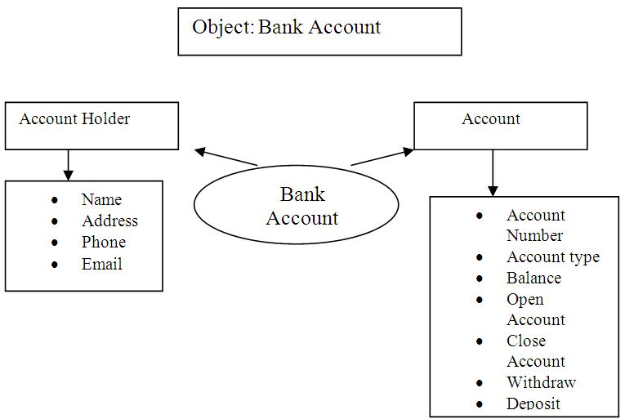

**Figure-2.1:** Bank Account System

Just by looking at the above picture, we can work out what methods we need our class to have:

**2.2.Methods**

* We need to be able to generate an account number
* Account types: Savings or Current Account
* Maintain/update Balance
* Open/Close Account
* Withdraw/Deposit

The next thing we need to look at is where to store the information about the account. Obviously, the best place to store information relating to bank accounts is in a database. To work with a database (from an OOP point of view) will require the following methods:

* Connecting to the database
* Inserting account details
* Updating the balance on any withdrawal or deposits made

Developed by Md. Jasim Uddin & Nuruzzaman (BCSE/28th Batch)

Our class will then be called Accounts and we will have a constructor method with the same name that will help us initialize some variables.

**2.3.Administrative Modules**

Here in my project there are two types of modules. This module is the main module which performs all the main operations in the system. The major operations in the system are:

**2.4.Admin Module**

Admin can access this project there is an authorization process. If you login as an Admin then you will be redirected to the Admin Home Page and if you are a simple user you will be redirected to your Account Home Page. This performs the following functions: Create Individual Accounts, Manage existing accounts, View all transactions, Balance enquiry, Delete/close account etc.

* Admin login
* Add/delete/update account
* Withdrawal/deposit/statements transaction
* Account Information
* User details list
* Active/Inactive account
* View transaction histories

**2.5.User Module**

A simple user can access their account and can deposit/withdraw money from their account. User can also transfer money from their account to any other bank account. User can see their transaction report and balance enquiry too.

* User login, use PIN system
* Creating/open new account registration
* Funds transfer (local/international/domestic)
* View statements transaction
* User account details
* Change Password and PIN

Developed by Md. Jasim Uddin & Nuruzzaman (BCSE/28th Batch)

* View about developer details

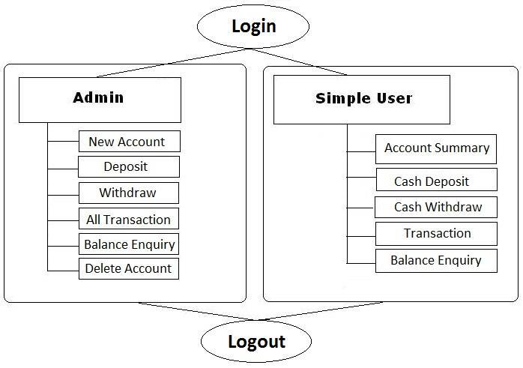

**Figure-2.2**: Module of project

**2.6.Hardware Requirements Specification**

Processor

Main Memory(RAM)

Cache Memory

Monitor

Keyboard

Mouse

Hard Disk

: Intel Pentium III or later

: 256 MB

: 512 KB

: 14 inch Color Monitor

: 108 Keys

: Optical Mouse

: 160 GB

**2.7.Software Requirements Specification**

|  |  |  |
| --- | --- | --- |
| Front End/Language | : | PHP |
| Back End/Database | : | MYSQL |
| Additional Tools | : | XAPM Server |
| Operating System | : | Windows 7, 8, 9, 10, XP |

Developed by Md. Jasim Uddin & Nuruzzaman (BCSE/28th Batch)



**System & Database Design**

**3.1.System design**

**3.2.Logical design**

**3.3.Physical design**

**3.4.Database design**

**3.5.Data flow diagram**

Developed by Md. Jasim Uddin & Nuruzzaman (BCSE/28th Batch)

**3.1.System Design**

Design is the first step into the development phase for any engineered product or system. Design is a creative process. A good design is the key to effective system. The term “design” is defined as “the process of applying various techniques and principles for the purpose of defining a process or a system in sufficient detail to permit its physical realization”. It may be defined as a process of applying various techniques and principles for the purpose of defining a device, a process or a system in sufficient detail to permit its physical realization. Software design sits at the technical kernel of the software engineering process and is applied regardless of the development paradigm that is used. The system design develops the architectural detail required to build a system or product. As in the case of any systematic approach, this software too has undergone the best possible design phase fine tuning all efficiency, performance and accuracy levels. The design phase is a transition from a user oriented document to a document to the programmers or database personnel.

**System** **design goes through two phases of development:**

* Logical Design and
* Physical Design.

**3.2.Logical Design**

The logical flow of a system and define the boundaries of a system. It includes the following steps:

* Reviews the current physical system – its data flows, file content, volumes, frequencies etc.
* Prepares output specifications – that is, determines the format, content and frequency of reports.
* Prepares input specifications – format, content and most of the input functions.
* Prepares edit, security and control specifications.
* Specifies the implementation plan.
* Prepares a logical design walk through of the information flow, output, input, controls and implementation plan.
* Reviews benefits, costs, target dates and system constraints.

Developed by Md. Jasim Uddin & Nuruzzaman (BCSE/28th Batch)

**3.3.Physical Design**

Physical system produces the working systems by define the design specifications that tell the programmers exactly what the candidate system must do. It includes the following steps.

* Design the physical system.
* Specify input and output media.
* Design the database and specify backup procedures.
* Design physical information flow through the system and a physical design Walk through.
* Plan system implementation.
* Prepare a conversion schedule and target date.
* Determine training procedures, courses and timetable.
* Devise a test and implementation plan and specify any new hardware/software.
* Update benefits, costs, and conversion date and system constraints.

**3.4.Database design**

The database, called a bank, will have two tables, one called accounts and the other called customer. Each will hold information about either the account or the customer. The two tables will be linked through a foreign key. The customer table has the following fields:

|  |  |  |  |  |
| --- | --- | --- | --- | --- |
|  |  |  | **Account User Table-3.1** |  |
|  |  |  |  |  |
|  | **Field** |  | **Description** |  |
|  |  |  |
|  |  |  |  |  |
|  |  |  |  |  |
|  | cusid |  | Creates a unique customer id for each new customer |  |
|  |  |  |  |  |
|  | name |  | Stores the customer name |  |
|  |  |  |  |  |
|  | address |  | Stores the customer address |  |
|  |  |  |  |  |
|  | acc_id |  | Links the customer to a account in the accounts table |  |
|  |  |  |  |  |

Developed by Md. Jasim Uddin & Nuruzzaman (BCSE/28th Batch)

|  |  |  |  |  |
| --- | --- | --- | --- | --- |
|  |  |  | **Accounts Table-3.2** |  |
|  |  |  |  |  |
|  |  |  |  |  |
|  | **Field** |  | **Description** |  |
|  |  |  |
|  |  |  |  |  |
|  |  |  |  |  |
|  | accid |  | Creates a unique account number for each new account |  |
|  |  |  |  |  |
|  | accno |  | Stores the account number |  |
|  |  |  |  |  |
|  | type |  | Stores the account type |  |
|  |  |  |  |  |
|  | balance |  | Stores the account balance |  |
|  |  |  |  |  |
|  | active |  | Shows the account status |  |
|  |  |  |  |  |

Since one customer can have many accounts, I thought it only right to insert a foreign key acc_id into the customer table. In addition, instead of having fields such as date created and date closed, I simply use the active field to check if the account is active or not. This will enable us to focus more on the programming than on particulars of the database.

**3.5.Data flow diagram**

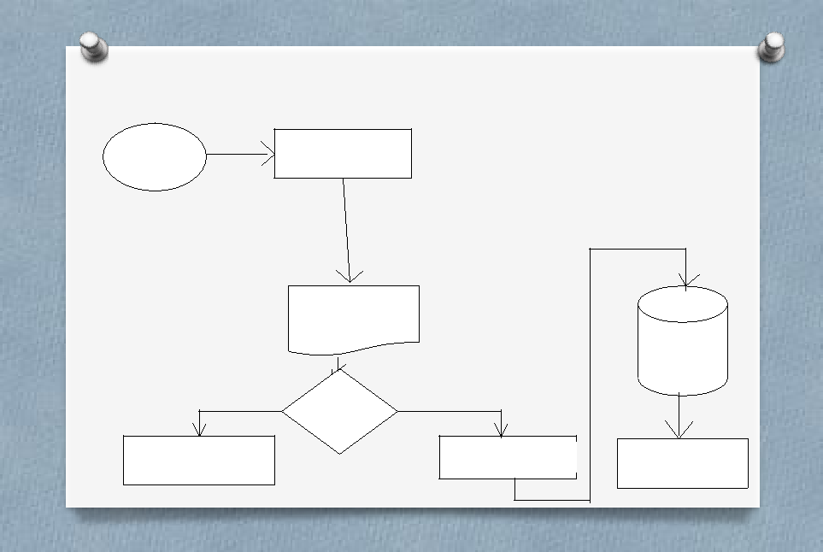

DFD diagram for Creating ”Account”

|  |  |
| --- | --- |
| User | New Acc |

|  |  |  |  |  |
| --- | --- | --- | --- | --- |
|  | New |  |  |  |
|  | Form |  |  |  |
|  |  |  | DB |  |
| No | Verify | Yes |  |  |
|  |  |  |  |
| Rejected |  | Create Acc | Created |  |
|  |  |  |  |

13

**Figure-3.1:** Create new account DFD

Developed by Md. Jasim Uddin & Nuruzzaman (BCSE/28th Batch)

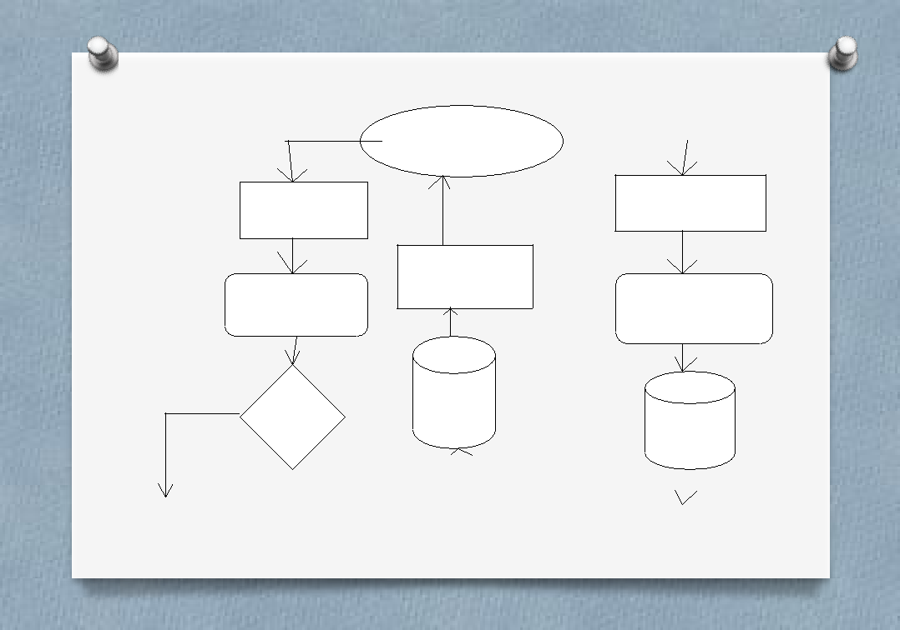

DFD diagram for withdraw/deposit ” Account”

User/Admin

|  |  |  |
| --- | --- | --- |
| Withdraw | Deposit |  |
|  |  |

|  |  |  |
| --- | --- | --- |
| Bank | Withdraw |  |
| Bank |  |
|  |  |

DB

Verify

DB

|  |  |  |  |  |  |  |  |
| --- | --- | --- | --- | --- | --- | --- | --- |
|  |  |  |  |  |  |  |  |
|  |  |  |  |  |  |  |  |
| No |  |  |  | Deposited | |  |  |
| Amount |  |  |  | 14 |  |
|  |  |  |  |  |  |
|  |  |  |  |  |  |  |  |

**Figure-3.2:** Withdraw/deposit account DFD

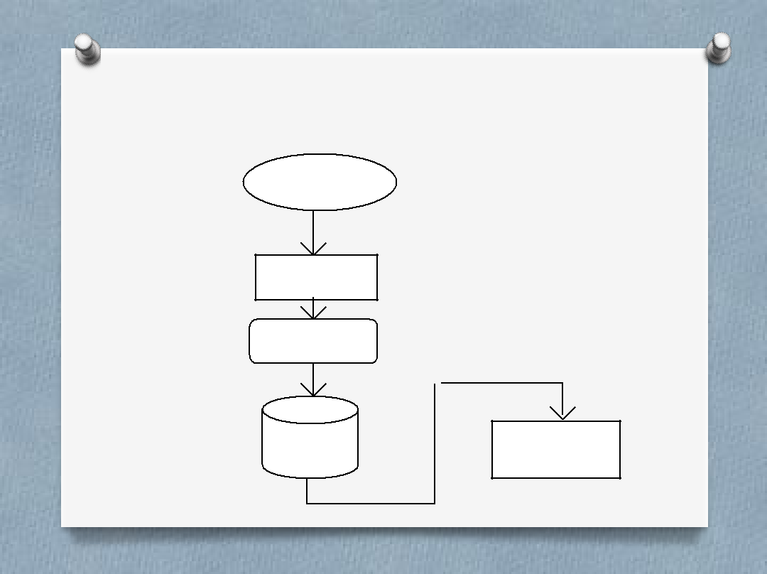

DFD diagram for deleting an “A/C”

Admin

Delete

Bank

Account

DB Deleted.

15

**Figure-3.3:** Deleting an account DFD

Developed by Md. Jasim Uddin & Nuruzzaman (BCSE/28th Batch)



**Terms of service & Security**

**4.1.General information**

**4.2.Security terms**

**4.3.Bank terms**

**4.4.Customer’s obligations**

**4.5.Dos & Don’ts**

**4.6.Safe online banking tips**

**4.7.Beware of phishing attacks**

Developed by Md. Jasim Uddin & Nuruzzaman (BCSE/28th Batch)

**4.1.General Information:**

1. You should register for BAMS bank with the branch where you maintain the account.
2. If you maintain accounts at more than one branch, you need to register at each branch separately.
3. Normally BAMS Bank services will be open to the customer only after he/she acknowledges the receipt of password.
4. We invite you to visit your account on the site frequently for transacting business or viewing account balances. If you believe that any information relating to your account has a discrepancy, please bring it to the notice of the branch by e-mail or letter.
5. In a joint account, all account holders are entitled to register, as users of BAMS Bank, but transactions would be permitted based on the account operation rights recorded at the branch. (To begin with the services will be extended only to single or Joint “E or S” accounts only).
6. All accounts at the branch whether or not listed in the registration form, will be available on the BAMS Bank. However the applicant has the option to selectively view the accounts on the BAMS Bank.

**4.2.Security terms:**

1. The Branch where the customer maintains his/her account will assign:
   * 1. User Account Number &
     2. Password
2. The User-id and Password given by the branch must be replaced by User Name and

Password of customer’s choice at the time of first log-on. This is mandatory.

1. Bank will make reasonable use of available technology to ensure security and to prevent unauthorized access to any of these services. The BAMS Bank service is VERISIGN certified which guarantees, that it is a secure site. It means that
   * You are dealing with RR at that moment.
   * The two-way communication is secured with 128-bit SSL encryption technology, which ensures the confidentiality of the data during transmission.
2. You are welcome to access BAMS Bank from anywhere anytime. However, as a matter of precaution, customers may avoid using PCs with public access.

Developed by Md. Jasim Uddin & Nuruzzaman (BCSE/28th Batch)

1. There is no way to retrieve a password from the system. Therefore if a customer forgets his/her password, he/she must approach the branch for re-registration.

**4.3.Banks terms:**

1. All requests received from customers are logged for backend fulfillment and are effective from the time they are recorded at the branch.
2. Rules and regulations applicable to normal banking transactions in India will be applicable mutatis mutandis for the transactions executed through this site.
3. The BAMS Bank service cannot be claimed as a right. The bank may also convert this into a discretionary service anytime.
4. Dispute between the customer and the Bank in this service is subject to the jurisdiction of the courts in the Republic of India and governed by the laws prevailing in India.
5. The Bank reserves the right to modify the services offered or the Terms of service of BAMS Bank. The changes will be notified to the customers through a notification on the Site.

**4.4.Customer’s obligations**

1. The customer has an obligation to maintain secrecy in regard to Username & Password registered with the Bank. The bank presupposes that login using valid Username and Password is a valid session initiated by none other than the customer.
2. Transaction executed through a valid session will be construed by RR to have emanated from the registered customer and will be binding on him/her.
3. The customer will not attempt or permit others to attempt accessing the BAMS Bank through any unlawful means.

**4.5.Dos & Don’ts:**

1. The customer should keep his/her User ID and password strictly confidential and should not divulge the same to any other person. Any loss sustained by the customer due to non-compliance of this condition will be at his/her own risk and responsibility and the Bank will not be liable for the same in any manner.

Developed by Md. Jasim Uddin & Nuruzzaman (BCSE/28th Batch)

1. The customer is free to choose a password of his/her own for BAMS Bank services. As a precaution a password that is generic in nature, guessable or inferable personal data such as name, address, telephone member, driving license, date of birth etc. is best avoided. Similarly it is a good practice to commit the password to memory rather than writing it down somewhere.
2. It may not be safe to leave the computer unattended during a valid session. This might give access to your account information to others.

**4.6.Safe Online Banking Tips**

* URL address on the address bar of your internet browser begins with "https"; the letter’s at the end of "https" means 'secured'.
* Look for the padlock symbol either in the address bar or the status bar (mostly in the address bar) but not within the web page display area. Verify the security certificate by clicking on the padlock.
* Do not enter login or other sensitive information in any pop up window.
* The address bar has turned to green indicating that the site is secured with an SSL Certificate.

**4.7.Beware of Phishing Attacks**

* Phishing is a fraudulent attempt, usually made through email, phone calls, SMS etc seeking your personal and confidential information.
* State Bank or any of its representatives never sends you email/SMS or calls you over phone to get your personal information, password or one time SMS (high security) password.
* Any such e-mail/SMS or phone call is an attempt to fraudulently withdraw money from your account through Internet Banking. Never respond to such email/SMS or phone call.
* Change your Internet Banking password at periodical intervals.
* Always check the last log-in date and time in the post login page.

Developed by Md. Jasim Uddin & Nuruzzaman (BCSE/28th Batch)



**Sample Snapshots of Project**

**5.1.Figures of BAMS**

**5.2.Admin section**

5.2.1.Home Page

5.2.2.Account information

5.2.3.User details list

5.2.4.Transaction statement

5.2.5.User profile

5.2.6.Modify E-mail

**5.3.User section**

5.3.1.Provide PIN

5.3.2.Open new account form

5.3.3.Statements history

5.3.4.Account details

5.3.5.Funds transfer

5.3.6.Security change

5.3.7.About developers

Developed by Md. Jasim Uddin & Nuruzzaman (BCSE/28th Batch)

**5.1.Sample Snapshots of Project**

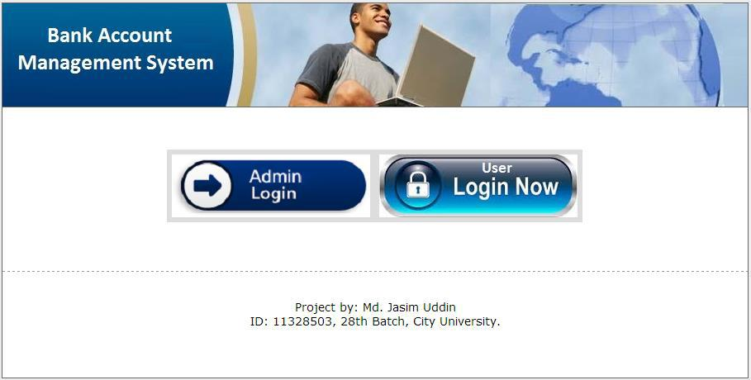

**5.2.Admin Login Section**

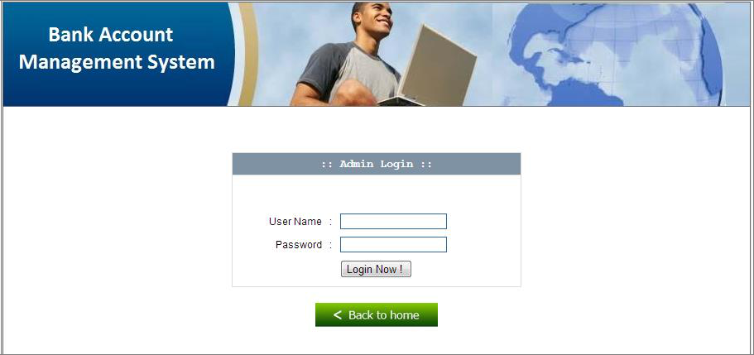

Developed by Md. Jasim Uddin & Nuruzzaman (BCSE/28th Batch)

**5.2.1.Admin Home page**

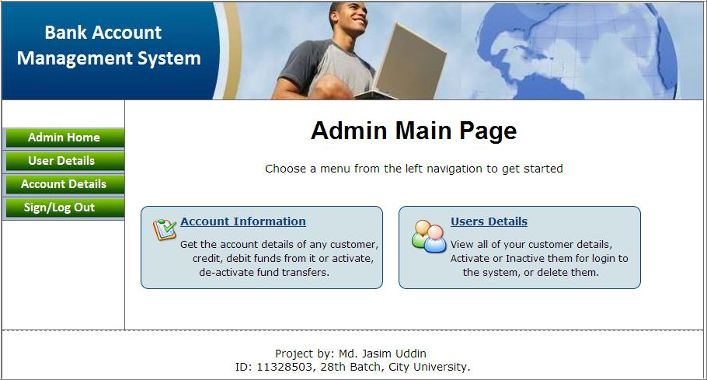

**5.2.2.Account Information**

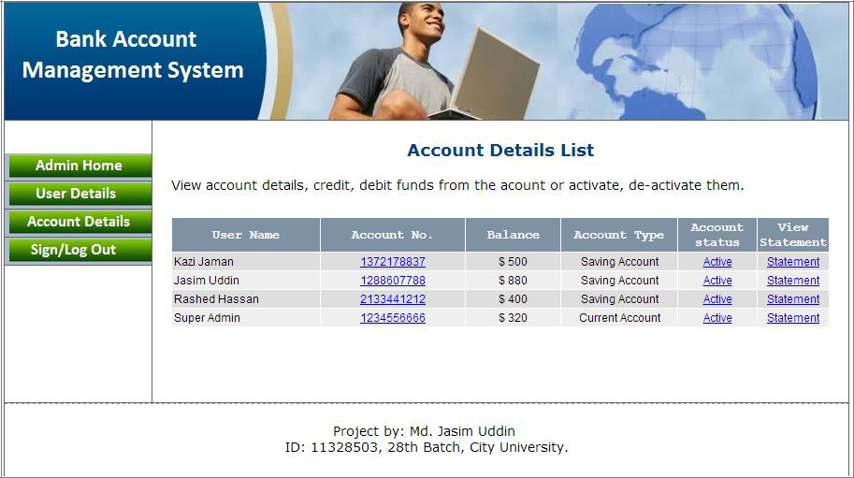

Developed by Md. Jasim Uddin & Nuruzzaman (BCSE/28th Batch)

**5.2.3.User Details List**

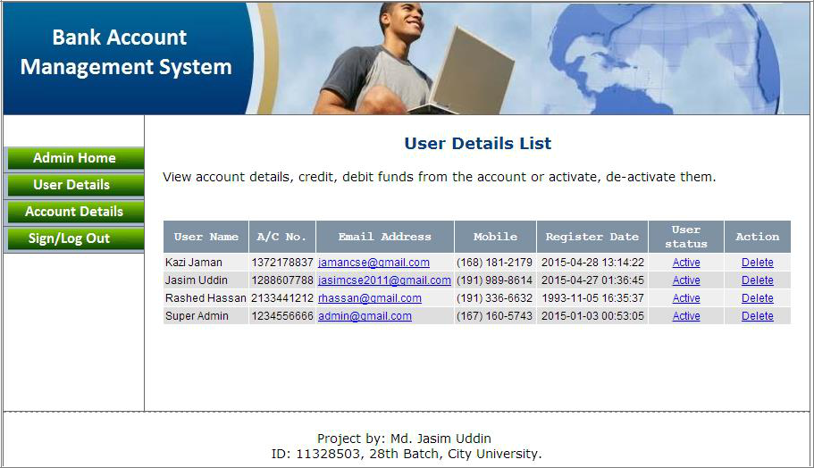

**5.2.4.User Account Transactions Statement**

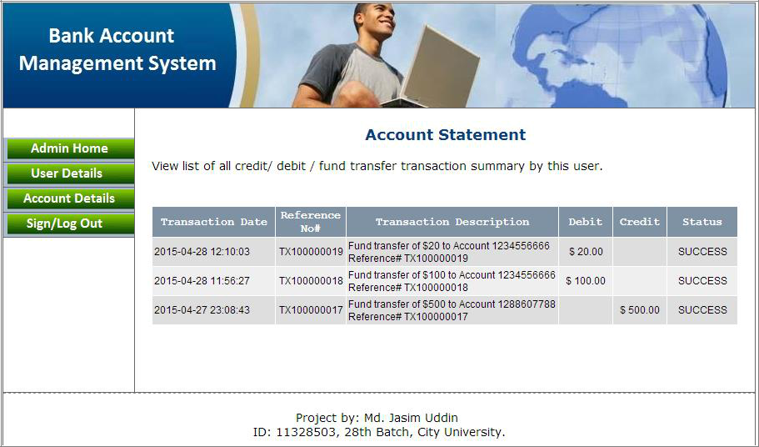

Developed by Md. Jasim Uddin & Nuruzzaman (BCSE/28th Batch)

**5.2.5.BAMS User Profile**

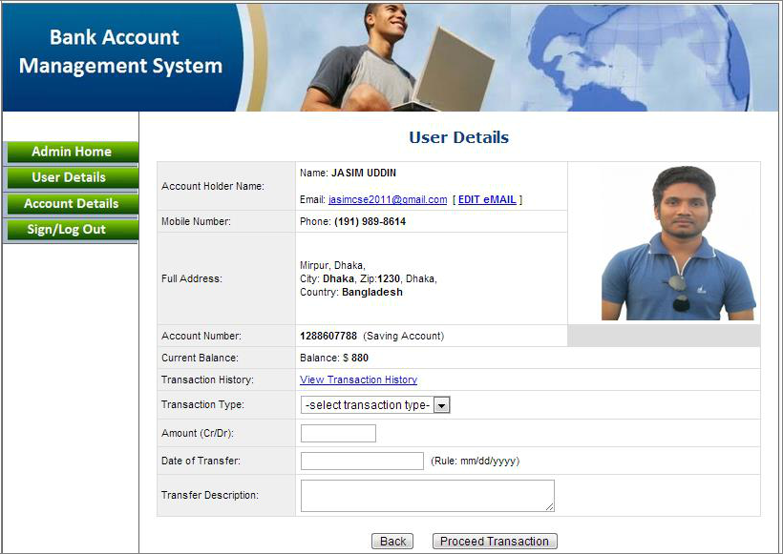

**5.2.6.Modify User E-mail**

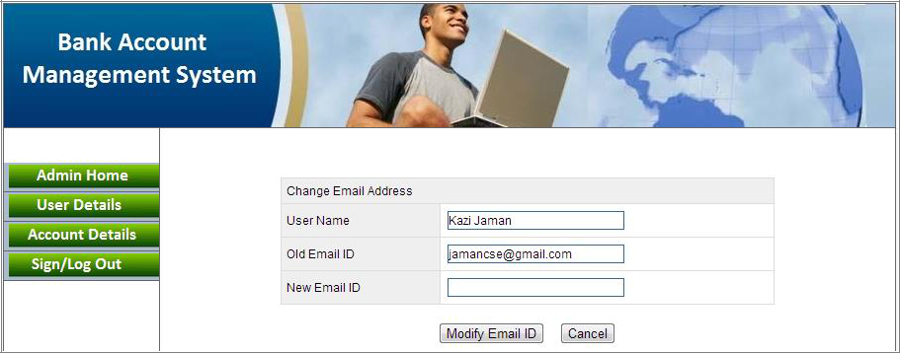

Developed by Md. Jasim Uddin & Nuruzzaman (BCSE/28th Batch)

**5.3.User Login Section**

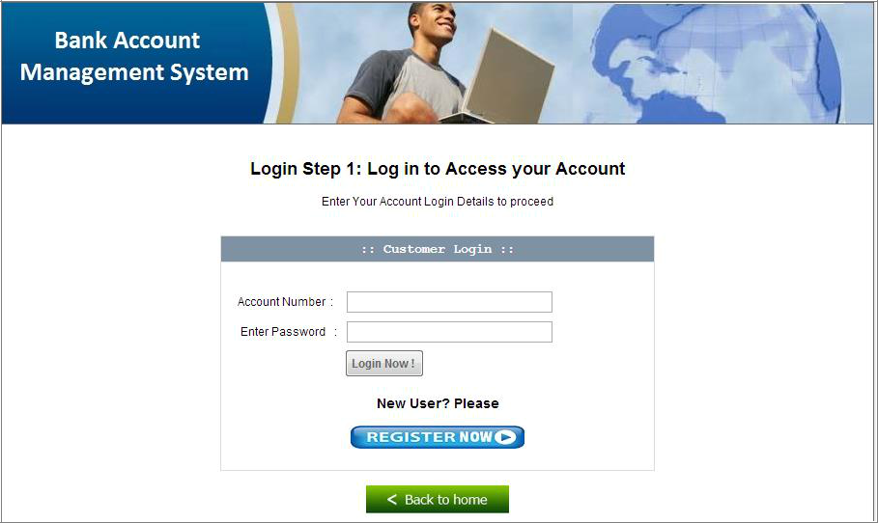

**5.3.1.Provide PIN**

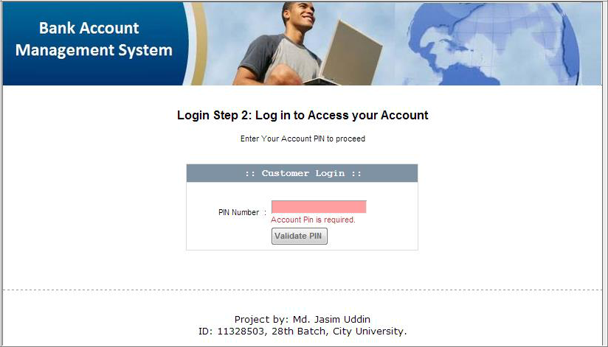

Developed by Md. Jasim Uddin & Nuruzzaman (BCSE/28th Batch)

**5.3.2.Open New Account/Register Form**

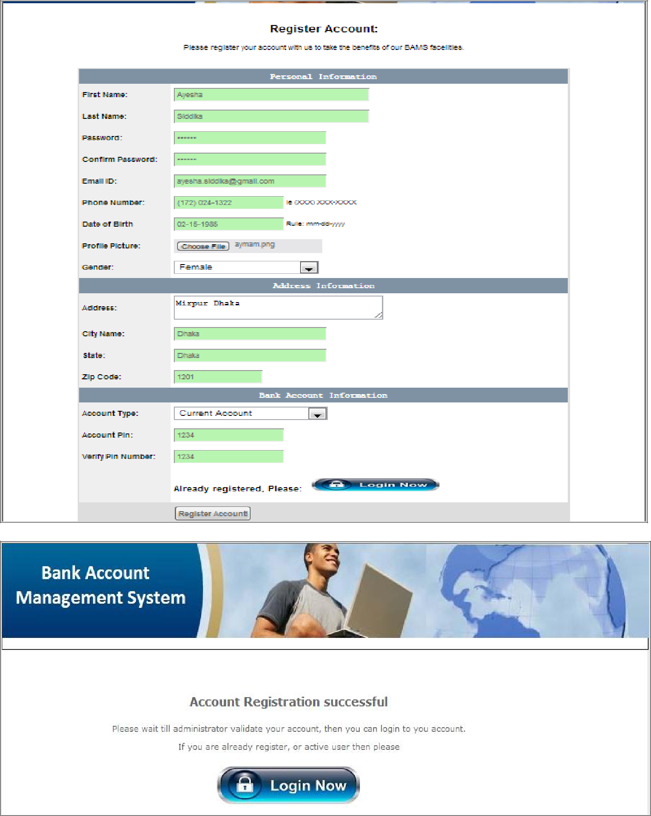

Developed by Md. Jasim Uddin & Nuruzzaman (BCSE/28th Batch)

**5.3.3.User Profile Home + A/C Statement**

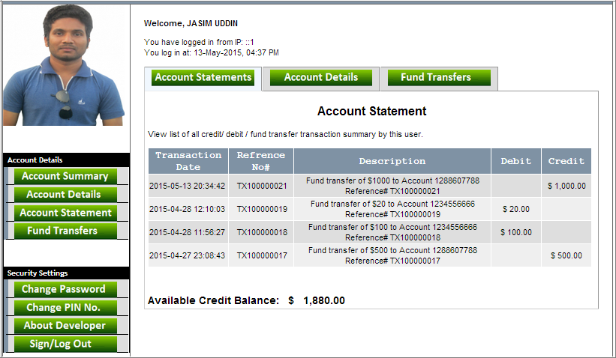

**5.3.4.User Account Details**

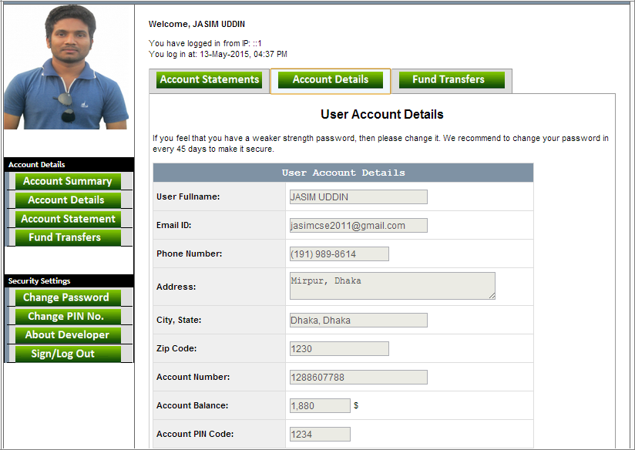

Developed by Md. Jasim Uddin & Nuruzzaman (BCSE/28th Batch)

**5.3.5.Funds Transfer System**

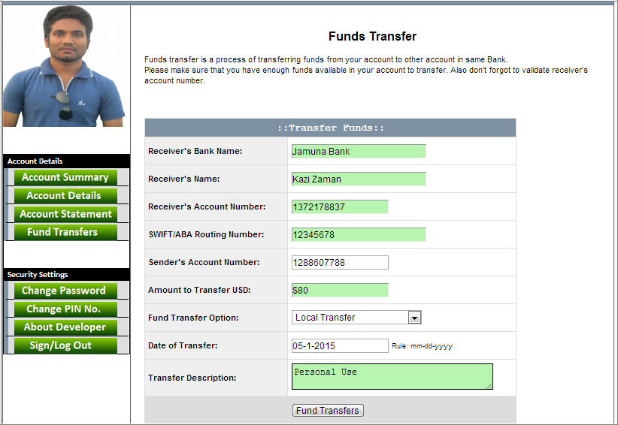

**5.3.6.Provide Transaction Authorization Code**

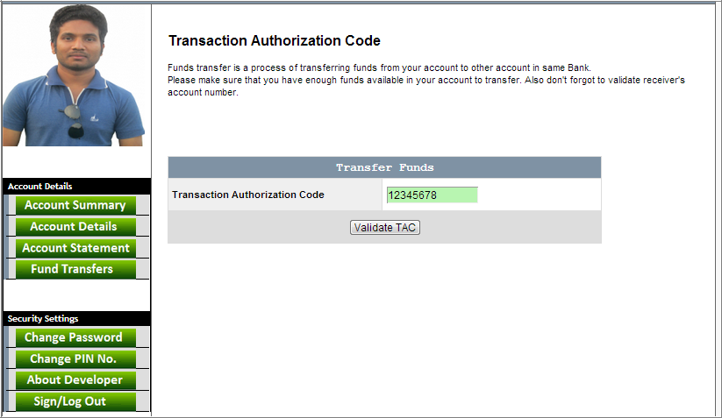

Developed by Md. Jasim Uddin & Nuruzzaman (BCSE/28th Batch)

**5.3.7.Security Change Sections**

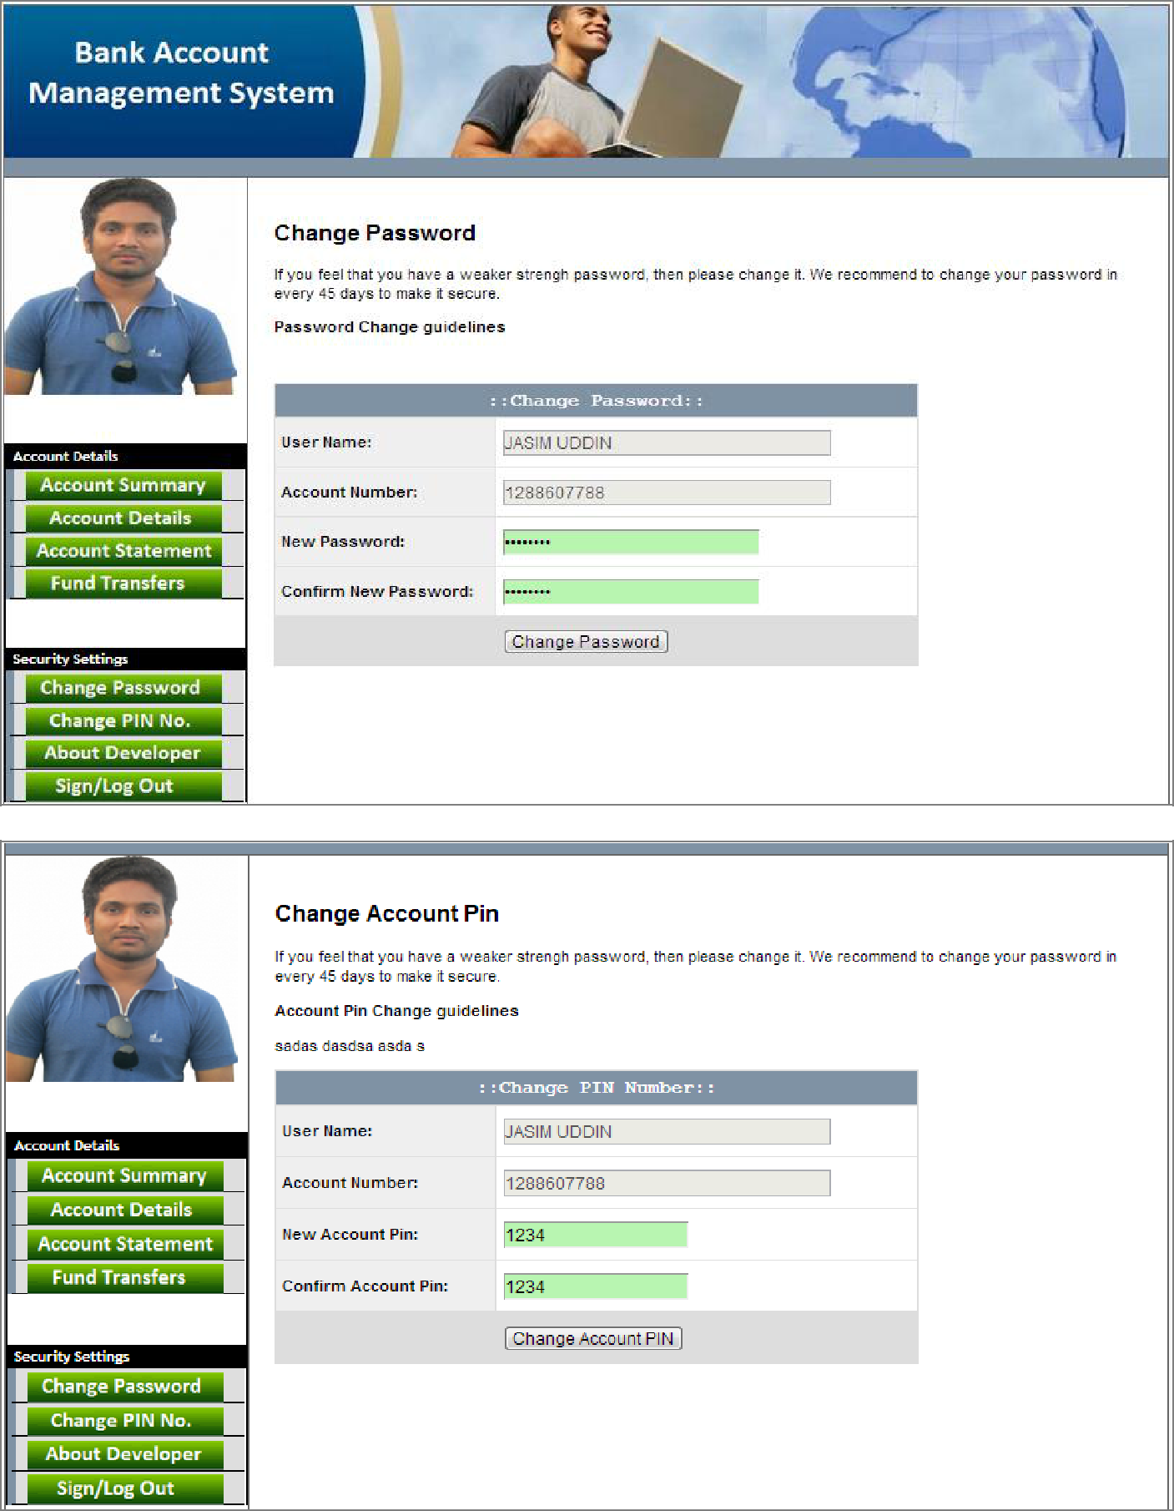

Developed by Md. Jasim Uddin & Nuruzzaman (BCSE/28th Batch)

**5.3.8.About Developers Section**

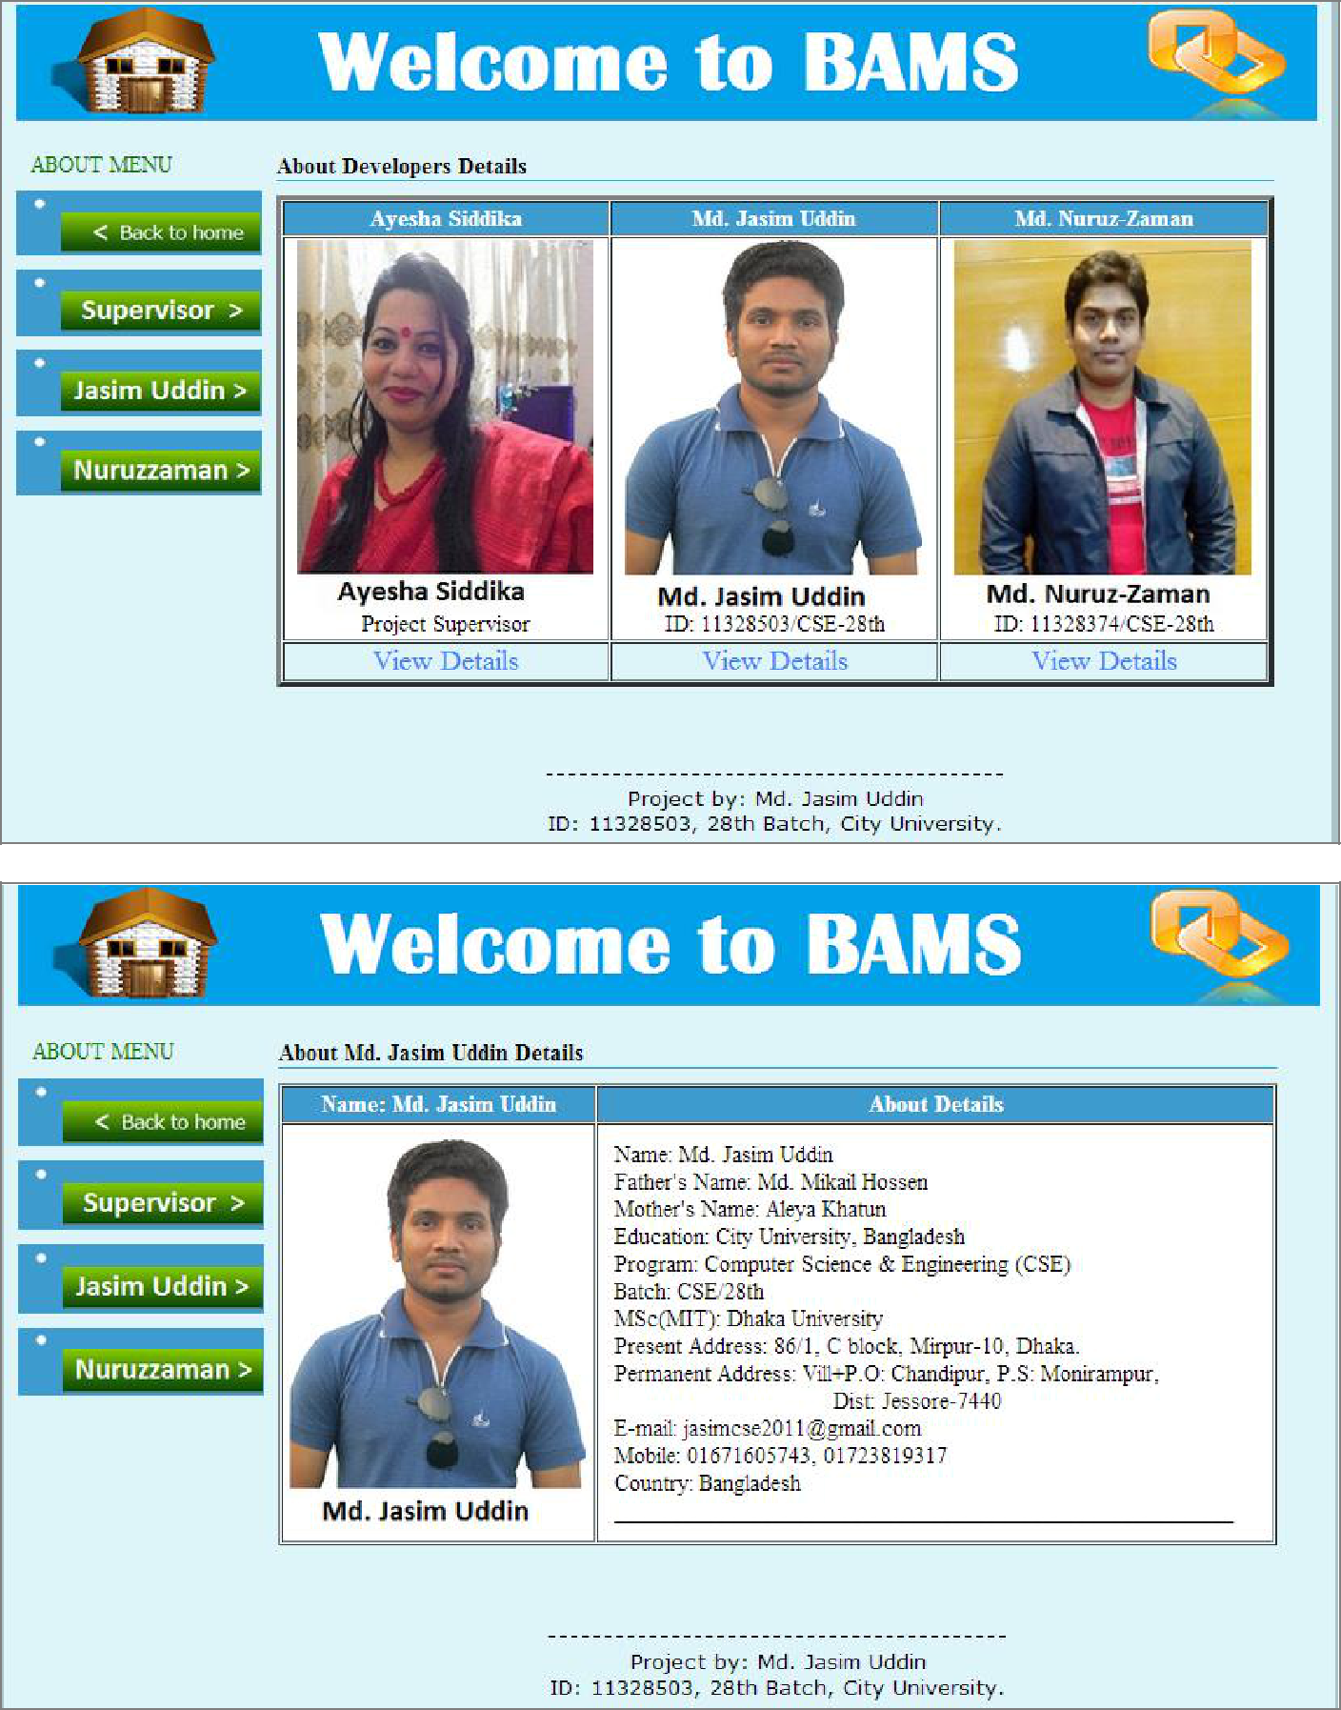

Developed by Md. Jasim Uddin & Nuruzzaman (BCSE/28th Batch)



**Conclusion**

**6.1.Benefits of online banking**

**6.2.Future look**

**6.3.Conclusion**

Developed by Md. Jasim Uddin & Nuruzzaman (BCSE/28th Batch)

**6.1.Benefits of online banking**

Many of us lead busy lives. Some of us are up before the crack of dawn, getting ourselves prepared so we can in turn get our families ready for the day. We rush to work, rush to get the kids to school, and at the end of the day we rush home only to brace ourselves for the next day. After a hectic day, the last thing you want to do is spend time waiting in line at the bank, or even the post office. That's where [Online Banking](https://www.key.com/business/key-business-online/business-online-banking-options.jsp) comes in. Many of the benefits of doing our banking online are obvious:

1. You don't have to wait in line.
2. You don't have to plan your day around the bank's hours.
3. You can look at your balance whenever you want, not just when you get a statement.

There are some hidden benefits too. As a young bank customer, you're just learning how to manage your money and observe your spending patterns.

Online banking allows you to watch your money on a daily basis if you want to. By keeping close tabs on your funds, you'll always be aware of what's happening in your bank account.

For those experienced spenders, this option is far more appealing than the sudden discovery that you're broke!

It's also helpful to watch how much interest you're gathering on investments and savings or what service charges you have incurred.

**6.1.1.Most available benefits**

1. Online banking with key bank is fast, secure, convenient and free.
2. Quick, simple, authenticated access to accounts via the web application.
3. Simply scalable to grow with changing system requirement.
4. Global enterprise wide access to information.
5. Improved data security, restricting unauthorized access.
6. Minimize Storage Space.

Developed by Md. Jasim Uddin & Nuruzzaman (BCSE/28th Batch)

**6.2.Future Look**

The “Banking Online System is a big and ambitious project. I am thankful for being provided this great opportunity to work on it. As already mentioned, this project has gone through extensive research work. On the basis of the research work, we have successfully designed and implemented banking online System. To know what the future of online banking looks like, it’s probably worth looking at the present – online banking isn’t *new*. When you think of online banking, you probably think about a computer (either a desktop or laptop), a three or four step security process and then an interface that lets you view the balance of your various bank accounts and credit cards, whilst permitting you to transfer money and pay bills. And you’re not wrong either. The most valuable future looks are following below:

* More branches of the bank, maybe it will be international, that means more ATM machines outside.
* Customer issues development based on their needs, so the help desk will be aware of their needs and easy to use.
* Developing a mobile App for banking system that help users to do the obtained his operations without go to the bank only he need to sign in using his A/C NO. And password and then use your own PIN. Finally the system will update automatically.

Developed by Md. Jasim Uddin & Nuruzzaman (BCSE/28th Batch)

**6.3.Conclusion**

This project is developed to nurture the needs of a user in a banking sector by embedding all the tasks of transactions taking place in a bank. Future version of this project will still be much enhanced than the current version. Writing and depositing checks are perhaps the most fundamental ways to move money in and out of a checking account, but advancements in technology have added ATM and debit card transactions. All banks have rules about how long it takes to access your deposits, how many debit card transactions you're allowed in a day, and how much cash you can withdraw from an ATM. Access to the balance in your checking account can also be limited by businesses that place holds on your funds. Banks are providing internet banking services also so that the customers can be attracted. By asking the bank employs we came to know that maximum numbers of internet bank account holders are youth and business man. Online banking is an innovative tool that is fast becoming a necessity. It is a successful strategic weapon for banks to remain profitable in a volatile and competitive marketplace of today. If proper training should be given to customer by the bank employs to open an account will be beneficial secondly the website should be made friendlier from where the first time customers can directly make and access their accounts.

Thus the Bank Management System it is developed and executed successfully.

Developed by Md. Jasim Uddin & Nuruzzaman (BCSE/28th Batch)

**Reference**

1. Fundamentals of database systems by (**Elmasri Navathe, 2000**),

Website:[https://archive.org/stream/FundamentalsOfDatabaseSystemselmasrinavathe#](https://archive.org/stream/FundamentalsOfDatabaseSystemselmasrinavathe#page/n51/mode/2up)

[page/n51/mode/2up,](https://archive.org/stream/FundamentalsOfDatabaseSystemselmasrinavathe#page/n51/mode/2up) Page: From **52** to more.

1. Article: **Online banking**, Website: <https://en.wikipedia.org/wiki/Online_banking>

**June 29, 2015, 12.30 am.**

1. Online Bank Account Management System

Website: [http://www.slideshare.net](http://www.slideshare.net/) (Collect some info for report documents, **2014-2015**)

1. Learning **MYSQL**, JavaScript, jQuery, **PHP**, **HTML**, CSS3, Website: [http://www.w3schools.comm,](http://www.w3schools.comm/) **2014-2015**
2. PHP and MySQL video tutorials, Oct **2014-2015**

Website: [http://www.freebanglatutorial.com,](http://www.freebanglatutorial.com/) [http://www.youtube.com](http://www.youtube.com/)

1. Veneeva, V. (2006), “E-Banking (Online Banking) and Its Role in Today's Society”,

Ezine articles, **June 30, 2015**

1. [JavaScript validation for empty input field,](http://stackoverflow.com/questions/3937513/javascript-validation-for-empty-input-field) (**May 10, 2015**)

Website:<http://stackoverflow.com/questions/3937513/javascript-validation-for-empty-input-field>,

1. JavaScript form validation: Validate **Password**, Validate **Email**, Validate **Phone** **Number**,[http://webcheatsheet.com/javascript/form_validation.php,](http://webcheatsheet.com/javascript/form_validation.php) **(May 10, 2015**)

Developed by Md. Jasim Uddin & Nuruzzaman (BCSE/28th Batch)

[View publication stats](https://www.researchgate.net/publication/301293322)